

**DESIGN THINKING REPORT**

**Smart Campus Data Solution: Improving Student Experience through Data**

**Topic 9 : Student Mental Health Insights**

**GROUP NUMBER** : 5 (*ERROR 404*)

**SUBJECT** : TECHNOLOGY AND INFORMATION SYSTEM (SECP1513)

**SECTION** : 02

**LECTURE NAME** : DR. ARYATI BINTI BAKRI

**GROUP MEMBER** :

|  |  |  |
| --- | --- | --- |
| MUHAMMAD HAFIZ BIN SUHAILI | NUR FARIZA ADLINA BINTI MOHAMMAD FAIZAL | GAN MEI LEE |
| A25CS01006 | A25CS0310 | A25CS0225 |

TABLE OF CONTENTS

**1.0 INTRODUCTION 2**

1.1 Design Thinking Process 3

1.1.0 Task Distribution 3

1.1.1 Emphatize 4

1.1.2 Define 10

1.1.3 Ideate 12

1.1.4 Prototype 13

1.1.5 Testing 17

**2.0 REFLECTION 18**

**3.0 CONCLUSION 19**

**4.0 REFERENCES 19**

# **1.0 INTRODUCTION**

Mental health is known as a fundamental component of broad well-being, yet it remains frequently underrepresented predominantly among men. Psychological disruptions which confine a wide spectrum of cognitive, emotional and behavioural inconsistencies, have the potential to disturb one’s daily functioning and interpersonal relationships. These conditions are often caused by stress factors, namely ineffective time management and academic workloads.

The emergence of psychological issues not only includes mood disorders, being shown as irritability or hopelessness. Some of the visible, physical signs include body weight increment and sleep disturbance, providing the insights of one’s mental health issue.

Mental health insight is defined as the understanding of one’s psychological condition, the detection of symptoms and the disastrous impact on quality of life. This design thinking project is dedicated to analyzing the mental health status, primarily among Universiti Teknologi Malaysia (UTM) students to propose a data driven solution that enhances the overall student experiences. The main objective is to identify and define existing mental health hurdles encountered throughout the duration of academic study.

Over a five-week timeline, the project was executed through a marginalized task distribution among all three group members, namely Analyst, Designer, and Editor. The collective progress and collaborative contributions made by all three group members were documented via the Github Project Board. Ensuring all members to track real-time progress, feedback and criticism and the quality control of project outcomes

## **1.1 Design Thinking Process**

### **1.1.0 Task Distribution**

| **Team Member** | **Role** | **Tasks** |
| --- | --- | --- |
| Muhammad Hafiz Bin Suhaili | Editor | * Record interview videos with respondents * Commence video editing via *Animaker* and *Capcut* * Improve multimedia aspect to ensure quality work produced * Create Google Docs with appropriate questions in order to complement Phase 1 - Emphatize * Monitor all progress to ensure no loopholes are present during development |
| Nur Fariza Adlina binti Mohammad Faizal | Analyst | * Initiates the report writing via Google Docs to ease collaboration between group members * Conduct and analyse data obtained through Google Forms and create visual aids * Create user journey map about the process to book an appointment through traditional methods |
| Gan Mei Lee | Designer | * Creates and enhance UI and UX development through *Canva* * Construct data flow diagram to ease the understand on how the data being utilised * Creates a mock-up application for proof-of-concept |

### **1.1.1 Emphatize**

In the commencement of the first week, a digital surveying tool was created and enhanced using the Google Forms platform to ease the distribution and the data collection process among UTM student population. This methodology was utilised to ensure a synchronous data-gathering process across multiple faculties. The survey was designed into three primary sections to provide proper insights of user experience, namely : User Demographics, Current Mental Wellbeing and Awareness and Barriers.

Quantitative data were collected from a sample of 71 respondents. To ensure the alignment of project objectives of identifying data related issues, these findings were represented via graphical charts. This visual evidence serves to give insight the core stressors and identify existing loopholes in the usage of campus wellness resources.

Google Form Respondent link : <https://forms.gle/vdtJujk3w6U7twY4A>

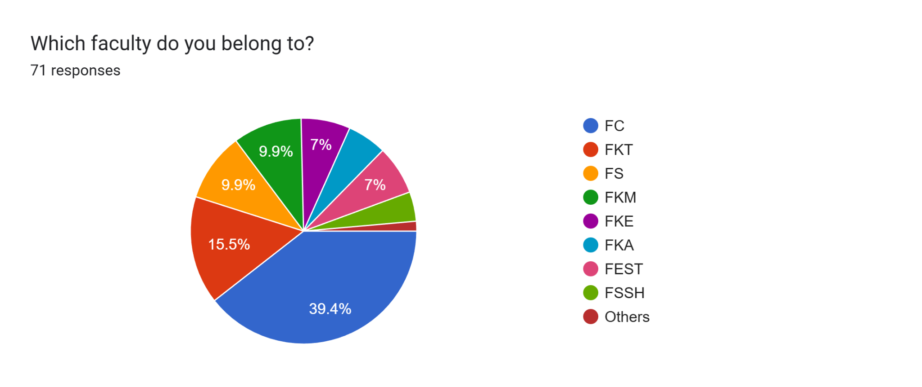

**Section 1 Question 1:** Which faculty do you belong to?

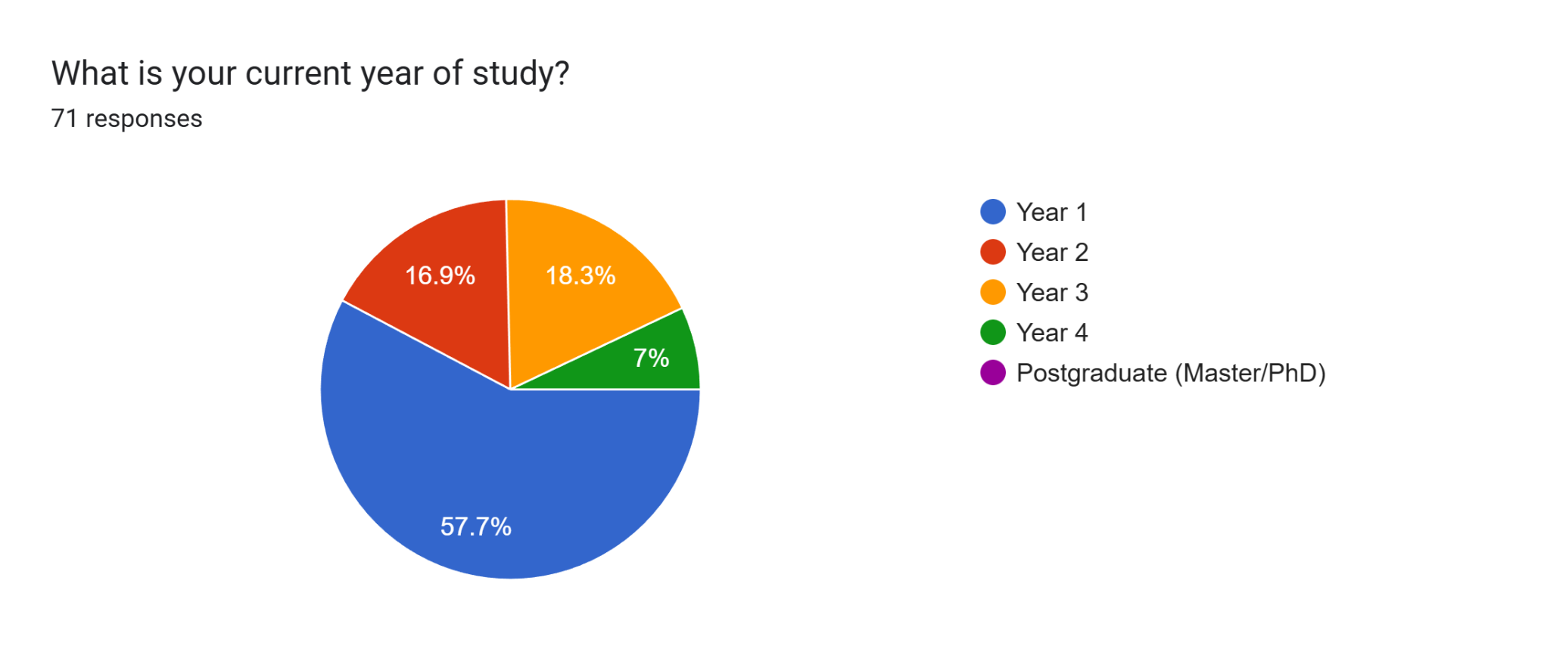

**Section 1 Question 2:** What is your current year of study?

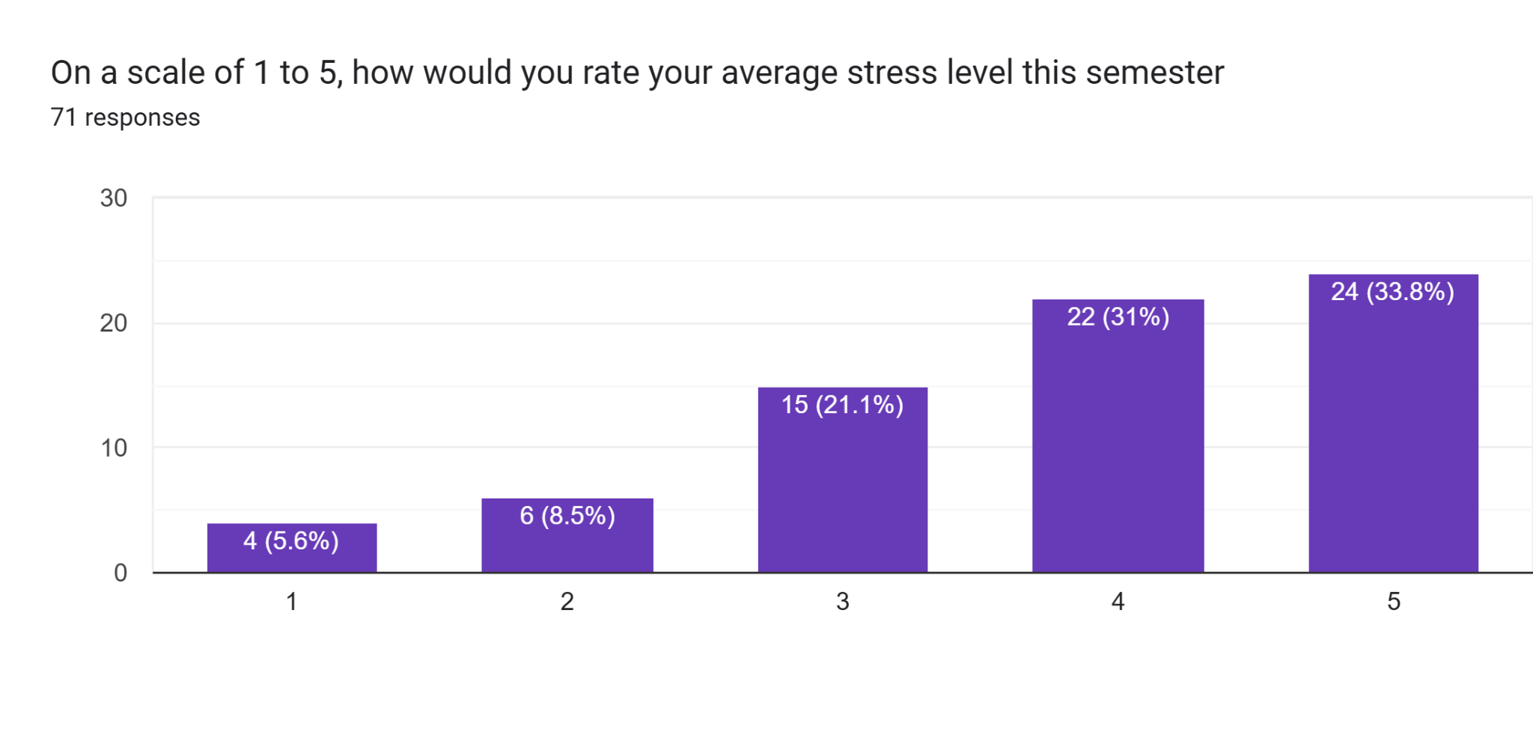

**Section 2 Question 1:** Average stress level throughout this semester

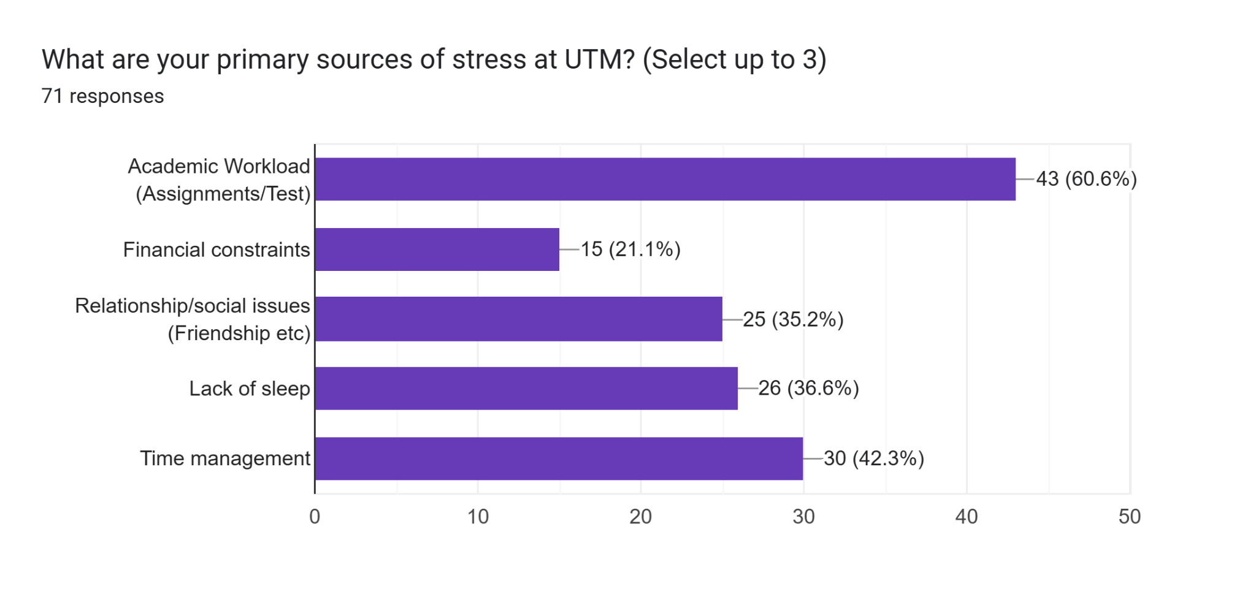

**Section 2 Question 2:**  Primary sources of stress at UTM

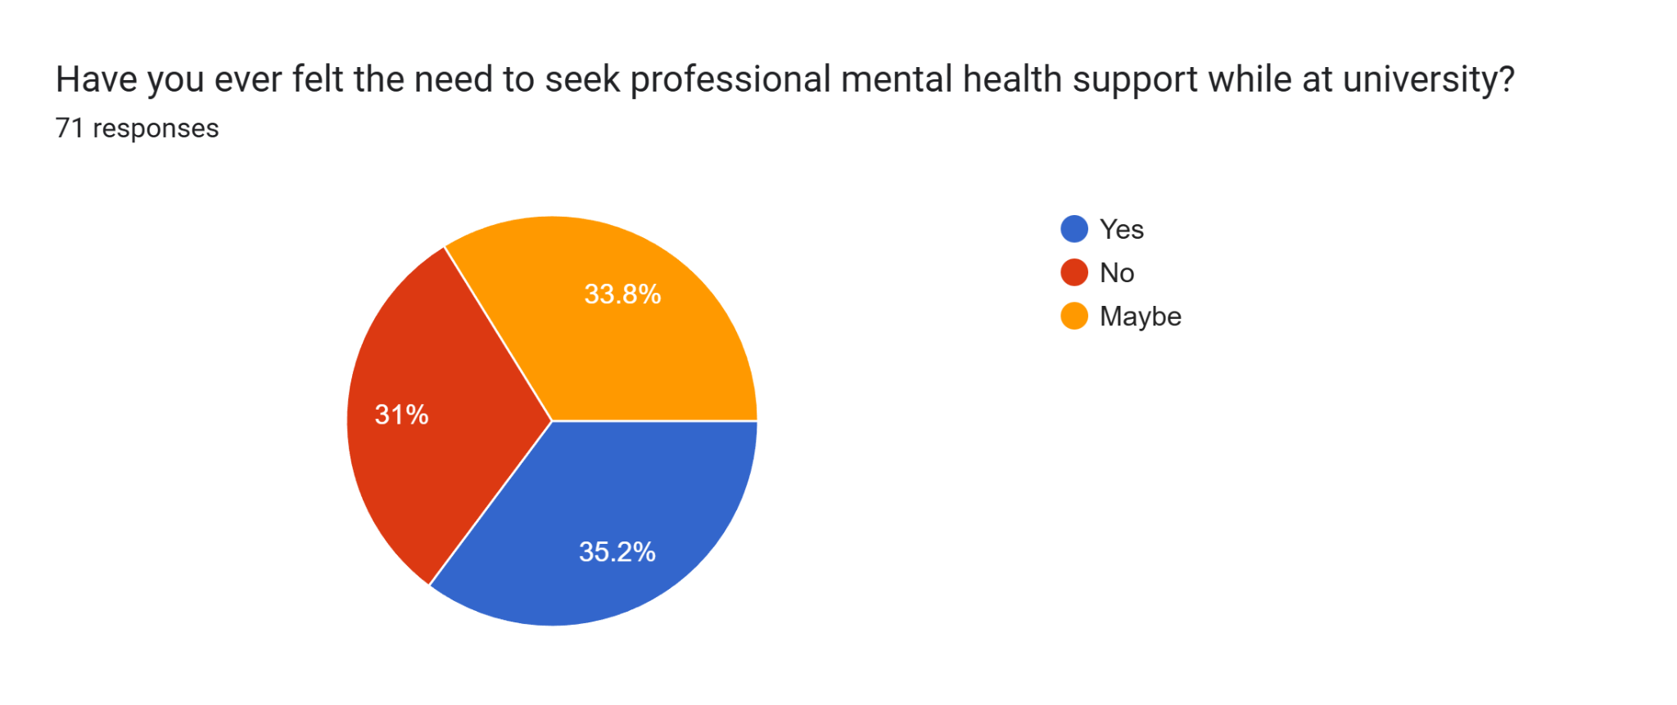

**Section 2 Question 3:** Need to seek professional mental health support

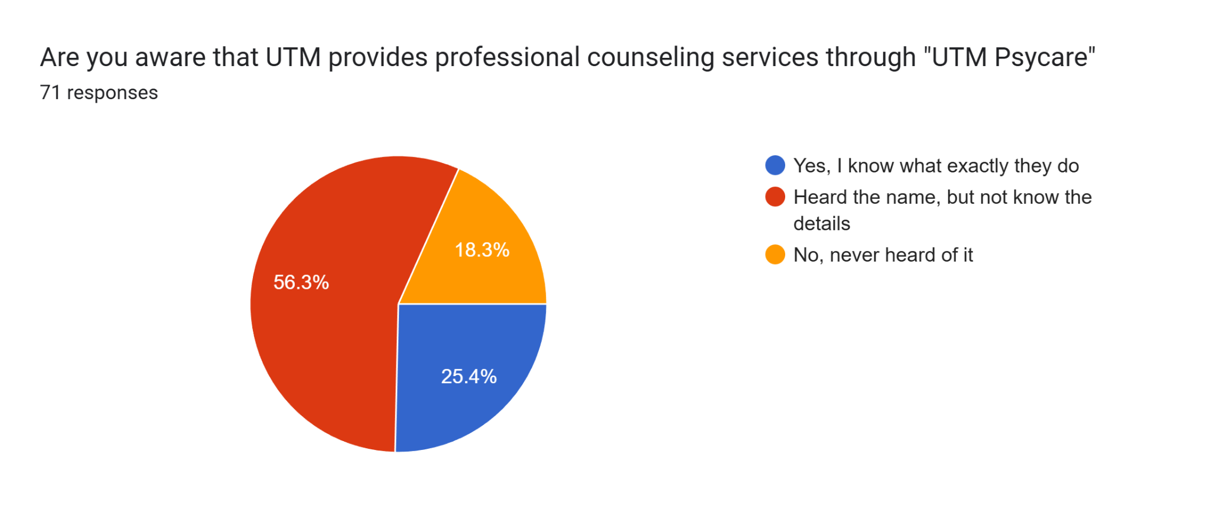

**Section 3 Question 1:** Awareness counseling services through UTM Psycare

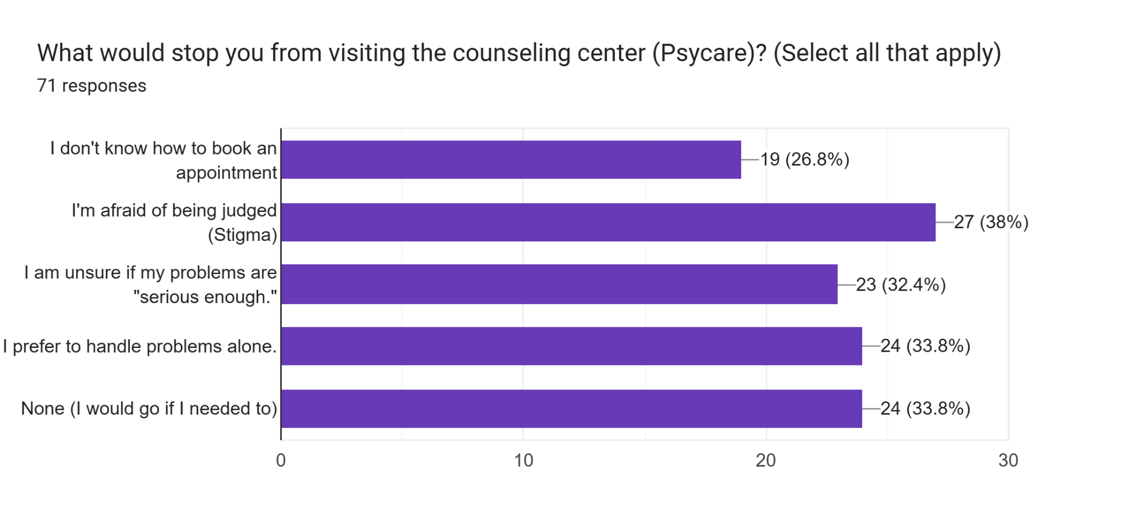

**Section 3 Question 2:** Reason for NOT visiting UTM Psycare

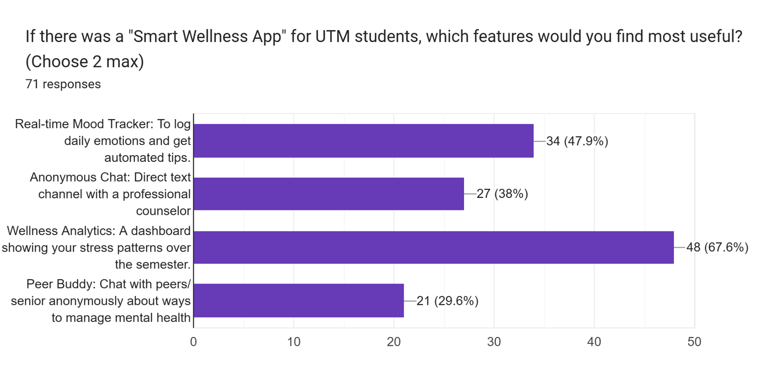

**Section 3 Question 3:** Features of “Smart Wellness App”

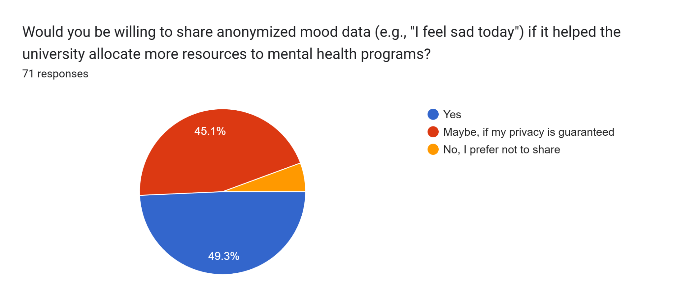

**Section 3 Question 4:** Anonymous data sharing to UTM in order to improve services

Above were the quantitative results from surveys shared through Google Forms. To obtain a much more authentic and qualitative response, we have conducted an interview with two consensual students to find out their opinion about UTM Psycare and mental health issues. The transcript of the interview were shown in the table below:

**Name :** MUHAMMAD HARIZ SYAHMI BIN MAHATHIR

**Faculty :** Computing

**Gender :** Male

**Year & Programme :** 1/SECPH

| **Question** | **Answers** |
| --- | --- |
| 1. Do you think men are more inclined to reject professional counselling services? Why? | I think men are more likely to reject counselling services because society forces them not to engage to not be seen as weak |
| 1. What are the contributing factors of stress based on your own experience studying in UTM? | Studying in UTM is very stressful because we don’t have easy access to counselling services without complicated procedure |
| 1. What improvement would you like in order for you to use UTM Psycare services in the future to manage your stress and mental health? | Those services should be integrated with UTM Smart and they should promote more mental-health related programme in the future |

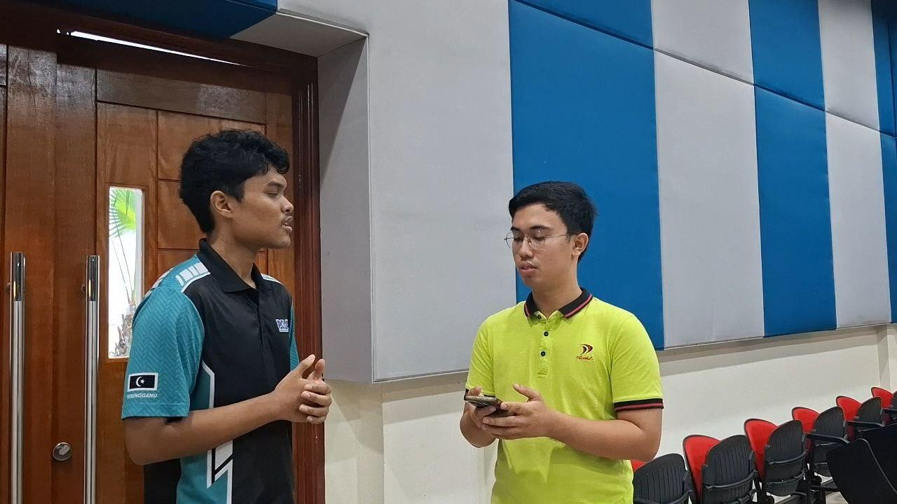

**Picture 1:** Interview with Hariz at Dewan Seminar Kejora, N28a, FC, UTM

**Name :** HUMAYRA’ BINTI ZULQARNAIN

**Faculty :** Computing

**Gender :** Female

**Year & Programme :** 1/SECPH

| **Question** | **Answers** |
| --- | --- |
| 1. Do you find it hard, as a first year student, to seek professional counselling help, booking appointments etc? | I am still finding myself adjusting to university life and I find that the system is pretty hard to find out how to book sessions. |
| 1. How often do you feel stressed? What are the primary sources that contribute to it? | Basically as usual, the academic overload, and especially at the end of the semester. Other than that, I also having trouble managing my time because I join so many activities |
| 1. Who do you trust the most to confess your emotions? What should UTM Psycare do to earn your trust? | I would tell my trusted friends. I would read counselor reviews on their website and also promote outreach programmes to other students to make sure they feel more comfortable, ensuring secrecy between counselor and students |

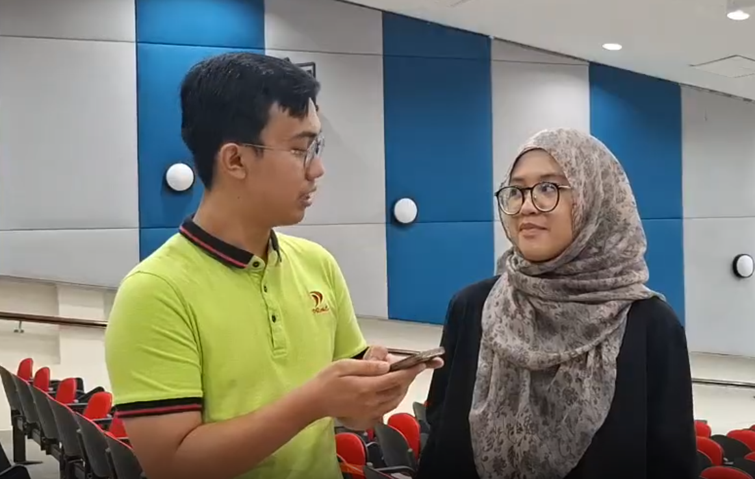

**Picture 2:** Interview with Humayra’ at Dewan Seminar Kejora, N28a, FC, UTM

### **1.1.2 Define**

Based on the empirical analysis of data obtained from the students, the main issue is explained through the following problem statements:

* **Academic and Time Pressure -**  it is observed that the current semester creates a conflict between rigorous curriculum standards and the students’capacity for effective time management. This tension is associated as a catalyst for psychological issues.
* **Infrastructure Awareness Gap -** While the existence of UTM Psycare is known by seniors, a critical issue is identified between student general awareness and the service provided by UTM Psycare sparks uncertainty and lack of information primarily among first year students. This widens the gap of trust among students and professional, certified counselors, subsequently causing mental health distress predominantly worse.
* **Sociopsychological Barriers -** The social stigma provides a misconception that professional disclosure will negatively affect their academic or social standing among the peers. In addition, the rise of the mindset of 'independent problem-solving’ is cited as a coping mechanism.

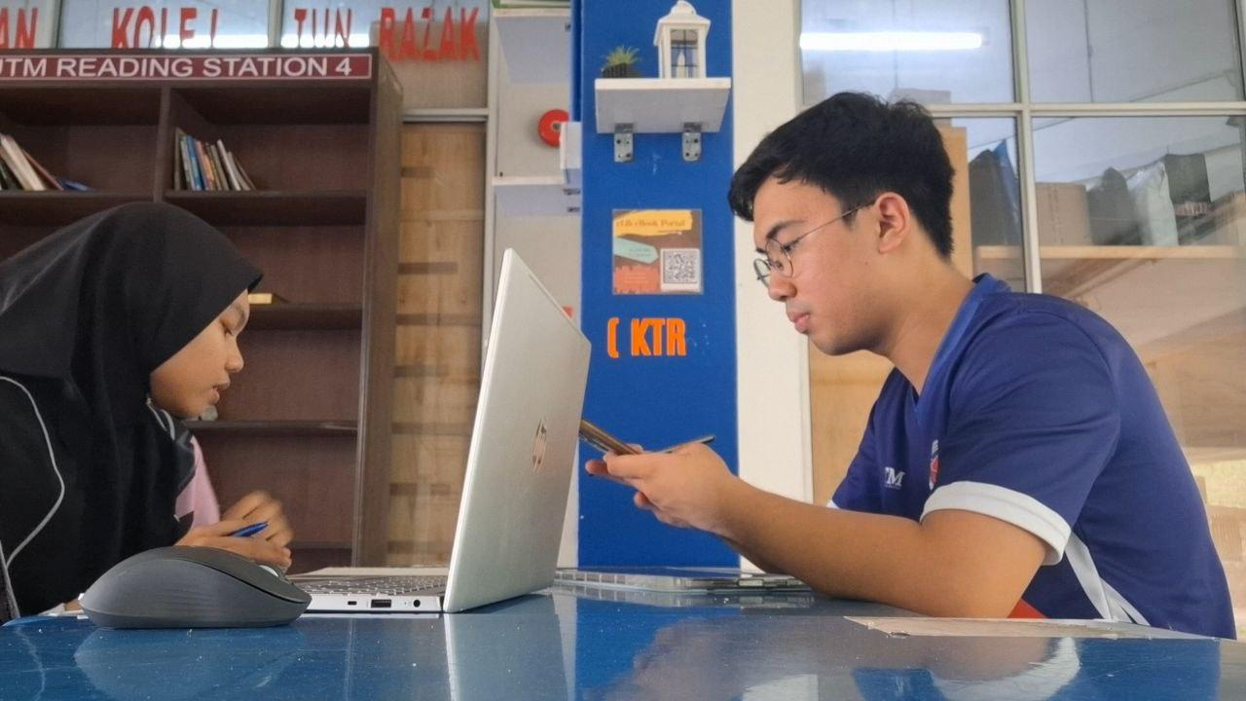

**Picture 3:** Brainstorm the problem statement at K01, KTR

User journey map:-

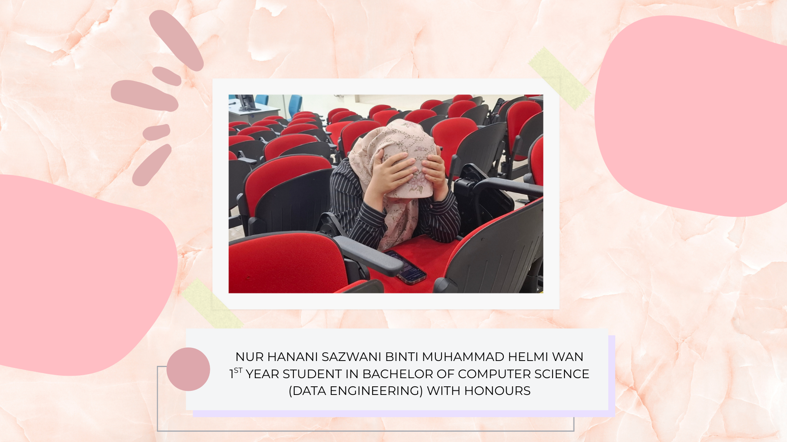

**Picture 4:** Persona Hanani Syazwani experiencing mental crisis

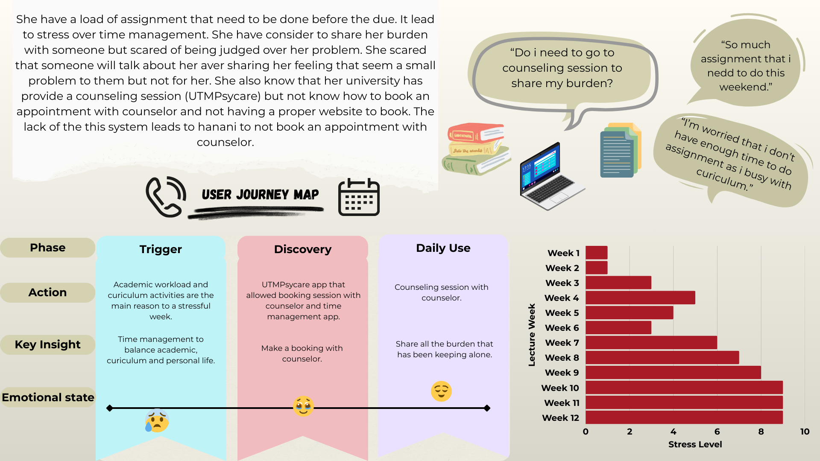

**Picture 5:** Hanani’s Journey Map

### **1.1.3 Ideate**

A comprehensive brainstorming session was conducted to identify seven potential interventions targeting the identified stressors that are present among respondents. This phase focused on the collaborative idea to develop a data-driven solution that enhances campus efficiency. After commencing thorough evaluation, a multifunctional integration within the UTMSMART application is known to be feasible, and scalable for the solution

The proposed solutions includes three core widgets or modules designed to combat the specific issues obtained during the Emphatize phase:

* **Time Management Widget -** A data-driven module integrated into the UTMSMART user interface to ease efficient academic and co-curricular scheduling, thereby combating stress caused from time management issue
* **Anonymized Consultation Chat -** A secure, real-time anonymous chat feature that operates within office hours, allowing for confidential communication with professional counselors, specifically engineered to bypass the identified issue related to social stigma
* **Optimized Appointment Booking -**  A streamlined booking system that are easily accessible via UTMSMART and the respective portals, advertising upcoming mental health related programme is designed to simplify the booking process to receive professional support

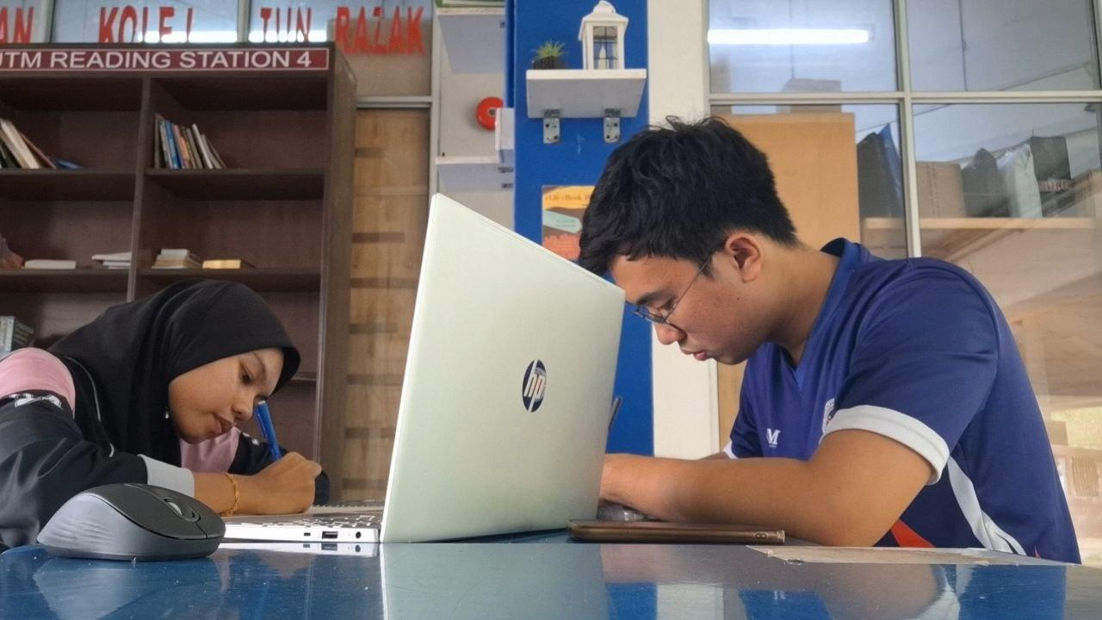

**Picture 6:** Brainstorm the solution at K01, KTR

### **1.1.4 Prototype**

In the last week, which is week five of the Design Thinking phase, the prototype was initialised via the application of Canva tool, facilitating the design process by the designer. The development focused on building a low-fidelity prototype to cater the data-driven solutions. Two interconnected digital interfaces were overhauled to cater the gaps:

* **UTMSMART integrations -** A mental health and time management widget was designed to existing mobile applications. The existing framework to centralise mental health resources. This modular addition was developed to provide a seamless user experience for accessing UTM Psycare information and scheduling widget.
* **Specialized Counselling Website -** A dedicated website for UTM Psycare was designed to optimize the appointment booking process. This interface was crafted to serve effective data collection and resource management, resulting into a more unified user experience compared to traditional processes

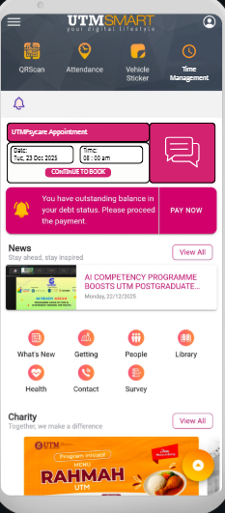

**Picture 7**: Integrate time widget in UTMSmart (Prototype 1)

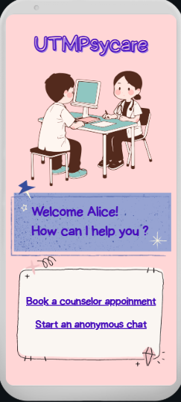

**Picture 8**: UTM Psycare Website for booking and anonymous chat (Prototype 2)

Based on user demands and practicality, we decided to use Prototype 1 as the primary solution. We believe that the integration of the widgets into UTM Smart app reduces redundancy for students to download new apps, as this app serves as ‘SuperApp’ to ease students' everyday life. A data flow diagram is made to visualise how the data is being used from the user end to the admin end.

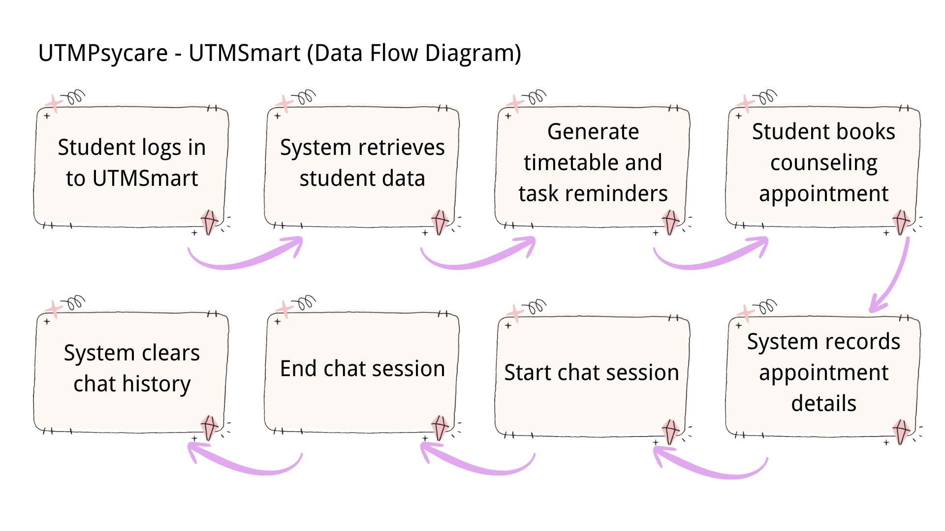

**Diagram 9**: Flow of booking system

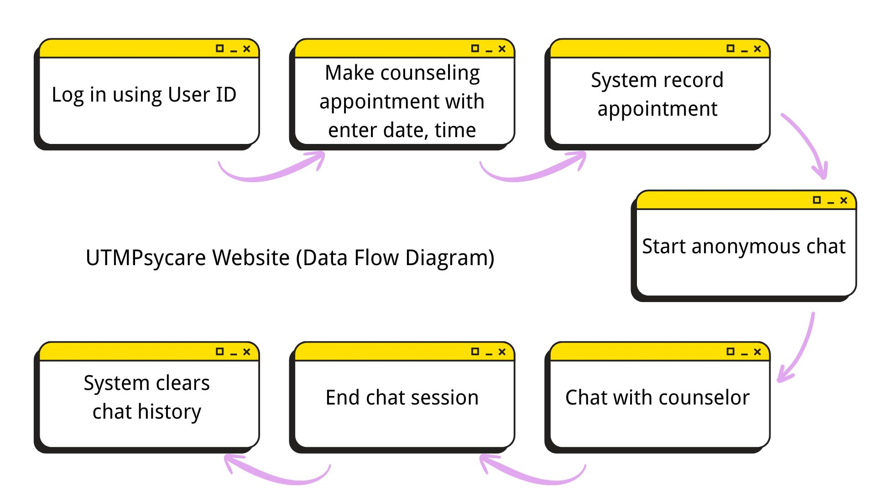

**Diagram 10**: Flow of chat anonymous in UTM Psycare website

### **1.1.5 Testing**

In week 6, we tested the program and got feedback from the users and suggestions for improvement.

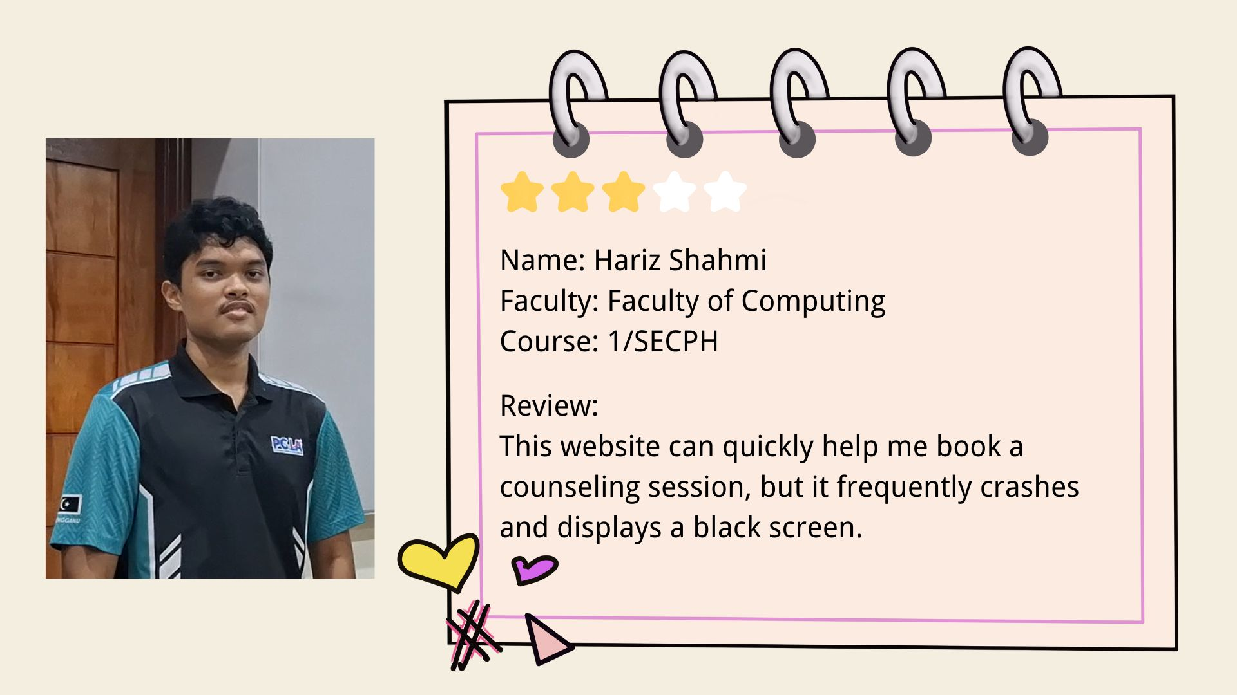

**Picture 1:** Feedback from user 1

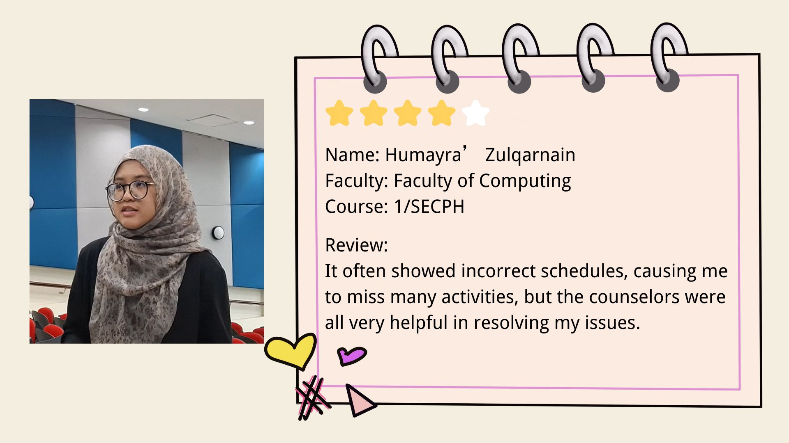

**Picture 2:** Feedback from user 2

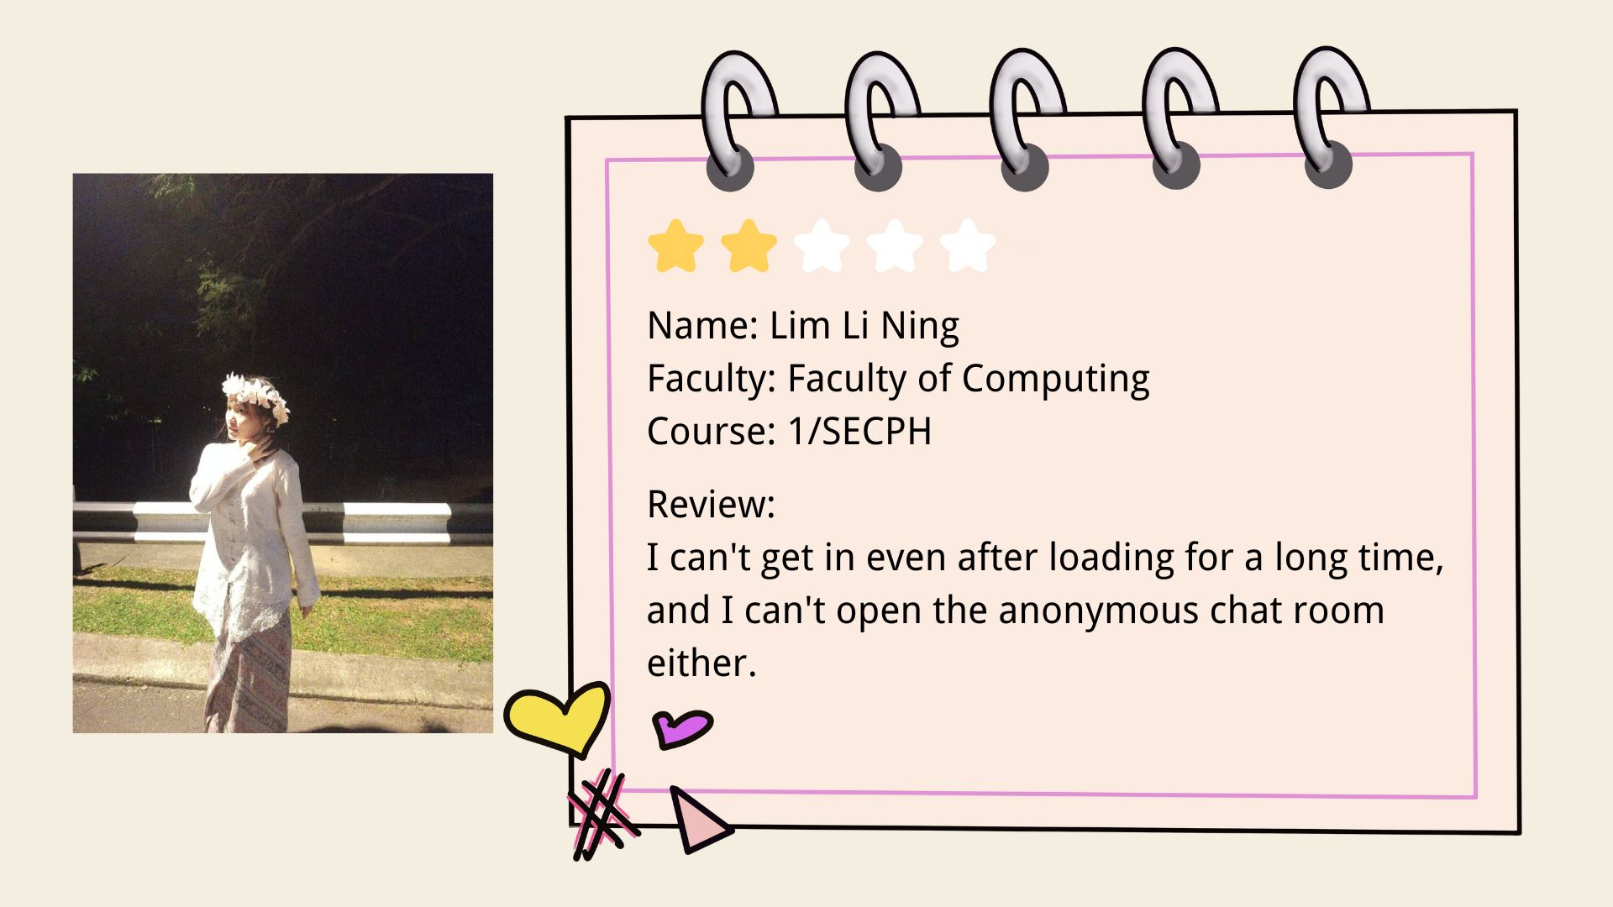

**Picture 3:** Feedback from user

# 2.0 REFLECTION

**Muhammad Hafiz Bin Suhaili**

Throughout the arduous journey of completing TIS assignments, it is undeniable that I’m aiming to master the vast knowledge of this subject, to give. Based on this project, it shed light to me that even exemplary students are haunted by mental health crises, waiting for an open hand to assist them, especially utilising UTM Psycare professional counseling services. In my humble opinion, the most impactful task in this project is Phase 1- Emphatize. It allows me to conduct interviews with other UTM students, to listen, synthesize and see their opinion from their point of view, ultimately leading to a much more understanding about the viable methods and ways to improve the existing UTM Psycare services. I believe that my time management skill especially in Agile methodology should be improved in order to ensure highest quality assignments can be produced in a nick of time

**Nur Fariza Adlina Binti Mohammad Faizal**

My goal is to enhance my critical thinking by learning how to create an app, program or website that is useful for people as programs or websites these days have a lot of cons. By doing this project, I can know what kind of steps I need to take and enhance my social skills along with my knowledge. Not to forget, I need to build a portfolio by documenting the design thinking process or updating my commitment to this course to improve my potential in the industry.

**Gan Mei Lee**

My dream is to become a data engineer that can build and manage data systems and can work in the technology industry in the future. Design thinking helps me improve my problem solving skills by solving the problem according to the user needs and improving the solution through rigorous testing and constructive feedback. To improve my potential in the industry, I want to strengthen my basic skills through practice with more projects, learning from my teammates. I also need to improve my team work to ensure the project can complete smoothly

# 3.0 CONCLUSION

Psychological stability is defined as a primary requirement for academic success, as the physiological and cognitive burnout associated with underlying stress significantly reduces a students’ ability for performance and consistency. A multi-faceted solution was crafted to circumvent the challenges identified within UTM students. The solution utilized optimized time management widget, anonymous chatroom and simplified booking system via UTMSMART.

The commencement of this project has made mental health support much more accessible to students via mobile platforms. This digital overhaul is critical to reduce sociopsychological issue such as stigma, by providing proper channel for professional engagement.

**Video link:**

<https://drive.google.com/drive/folders/1C5ZGtGp_phNOASKv_is6ifP2vMHVsOqJ?usp=drive_link>

# 4.0 REFERENCES

* *How to write in an academic style. (2024, September 18). The University of Sheffield.* [*https://sheffield.ac.uk/study-skills/writing/academic/style*](https://sheffield.ac.uk/study-skills/writing/academic/style)
* *Pathways Family and Community Services. (2024). Pathways Family and Community Services.* [*https://pathwaysfcs.com/mental-health-matters-key-insights-and-tips*](https://pathwaysfcs.com/mental-health-matters-key-insights-and-tips)
* *UXPin. (2016, January 16). What Is a Prototype: A Guide to Functional UX. Studio by UXPin.* [*https://www.uxpin.com/studio/blog/what-is-a-prototype-a-guide-to-functional-ux/*](https://www.uxpin.com/studio/blog/what-is-a-prototype-a-guide-to-functional-ux/)
* *Gibbons, S. (2018, December 9). Journey Mapping 101. Nielsen Norman Group.* [*https://www.nngroup.com/articles/journey-mapping-101/*](https://www.nngroup.com/articles/journey-mapping-101/)